D. Comparison QMFM and NBR-QPM (IMF-NBR 2020): issues/questions

1A. Fiscal impulse and aid impulse
 |  | QMFM | NBR-QPM
1 | Govt demand for G&S | gdem_gap drives directly output gap  gdem follows fiscal policy rule | is implicit in fiscal impulse
2 | Fiscal impulse, in % of GDP | =change in struct deficit + level discretionary deficit (gdem+oexp-grev)  determinant of private cons & inv gaps indirectly | =change in cyclically adjusted deficit = change in structural deficit + change in discretionary deficit  determinant of output gap (IS)
3 | Exceptional spending | part of spending (tiny, stable)  ignored | Except. spending excl, from deficit, change in except. spending added to fiscal impulse; rationale?
4 | Aid funded spending | part of spending and deficit, ignored as own driver of spending | aid and aid-funded spending excluded from deficit (how is aid defined?)
 | Aid impulse,  in % of GDP | aid-funded spending is part of gdem for G&S and deficit, under 1 and 2 | =change in aid/GDP gap (from trend)  determinant of output gap (IS)
5 | Fiscal rules | structural deficit/GDP follows AR(1) toward ss | structural deficit/GDP follows AR(1) toward ss
 |  | cyclical deficit/GDP follows output gap | cyclical deficit/GDP follows output gap
 |  | discretionary deficit and gdem follow AR(1), largely exogenous

--How is aid defined: all project/budget grants and loans? If so the deficit in fiscal impulse is equivalent to domestic financed deficit.
--How is aid measured: only reporting on budget grants and loans disbursed, no accurate reporting on project grants and loans spent; spending on budget G&L mostly lags disbursements, shortfalls in budget G&L offset by domestic financing (program adjustors)
--Does aid really drive govt demand or just finances planned spending? In QMFM, govt spending and deficit decisions are driven by their “rules” (trend-levels and steady states), with cyclical components and somewhat sluggish discretionary components.
--Why is aid impulse defined as the change in the aid-funded spending deficit/GDP gap? (i.e., change in aid-funded spending deficit/GDP minus change in aid(-funded) deficit trend). Why correct for a change in aid trend? (while fiscal impulse is defined as the change in deficit/GDP).
1B. Aggregate demand(IS curve)
 |  | QMFM | NBR-QPM
 | driver | 5 aggregate demand components (gaps) | output (non/agriculture)
1 | RIR | affects private consumption & investment  real IB interest rate gap + lending premium (dl_cpi_core{+1}) + prem_d  average 4Q ahead | affects output gap  real IB interest rate gap  (d4l_cpi_headline{+1})
2 | RER | affects exports and imports for G&S  RER (CPI_core) | affects output gap  RER (CPI_headline)
3 | Real GDP tr. partners | affects exports for G&S | affects output gap
4 | fiscal policy | affects govt demand for G&S directly  fiscal impulse affects private cons & inv indirectly (via disposable income) | fiscal impulse (excl. aid-financed spending) and aid-financed spending) affect outputgap

2. Inflation (three Phillips curves and Headline as weighted sum)
 |  | QMFM | NBR-QPM
1 | weights | NISR fresh food 0.16  NISR energy 0.07  NISR core 0.77 | all food and alcohol/tobacco 0.32  NISR energy 0.07  core 0.61
2 | “imported  inflation” for all CPIs | direct effect (PM* ER) and  indirect effect (REER gap) | only indirect effect (REER gap)
3 | CPI_food | agric. output gap is a driver (- sign) | agric. and non-agric. output gap are drivers  (opposite signs)
4 | CPI_ener | No output gap as driver | non-agric. output gap is a driver
5 | urban only | Rationale for Use of urban CPI in our macro models (FPAS, intMF,…)?  (also inconsistent with N.A. with has total consumption deflator

3. Exchange rate and RER
 |  | QMFM |  |  |  | NBR-QPM (IMF-NBR WP 2020)
1 | Exchange rate rule | In line with so-called hybrid approach in literature, both are combination of:  response to interest differential (UIP) with expected ER{+1} & move to target ER change; target ER change moves to trend REER change plus target inflation differential
2 | drivers | The reduced forms are almost the same and a function of:
 |  | l_s+{+1} | l_s+{-1} | dl_s_tar | (i - istar - prem)/4) | l_s+{-1} | l_s+{-1} | dl_s_tar | (i - istar - prem)/4)
 |  | 0.4 | 0.96 | 1.12 | 0.2 | 0.1 | 0.9 | 1.3 | 0.5
 |  | little | persistent |  |  | little | persistent | larger total effect | higher UIP weight
3 | dl_s_tar | includes an AR(1) |  |  |  | no AR(1), faster move to target ER change
inflation deviation term (coeff.<0) : if above target, less fast depreciation rationale?
REER-gap term (coeff.<0) : if positive, less fast depreciation redundant?
4 | REER in ER target | uses core inflation |  |  |  | uses headline inflation

4. Interest rate and RIR (modified Taylor rule)
 |  | QMFM | NBR-QPM
1 | Model policy rate | IB rate affected by CBR, not modeled difference recently dropped to <0.5% | CBR rate; premium for IB above CBR, tending to 1.5% in SS
2 | responses | inflation deviation 4Q ahead  d4l_cpi{+4} - d4l_cpi_tar coeff. 0.10  output gap coeff. 0.10 | Inflation deviation 1Q ahead  d4l_cpi{+1} - d4l_cpi_tar{+1} coeff. 0.05  non-agricultural outputgap coeff. 0.10
 |  | ER change deviation from target has zero coefficient (unlike NBR(2015, 2018) )
3 | real interest trend, r_tnd | = (rstar_tnd + prem + e_dl_z_tnd)  0% 2% 0%  higher country risk, 2-5%? | = [r_tnd{-1}, (rstar_tnd + prem + e_dl_z_tnd) ]  1% 1% 0%  slower move to steady state real interest rate
4 | neutral nominal rate, i_tnd  for CBR | = r_tnd + d4l_CPI_tar_core (target)  CPI_tar adj. for trend rp_core /headline  2 + 4.5 = 6.5%  n.a. | = r_tnd + dl_CPI{+1} (expected headline)  2 + 5=7%  deduct premium^{IB} (1.5% in ss) 7-1.5 = 5.5%  AR(1) process for IB premium
5 | RIR policy | i – e_dl_CPI_core{+1} in terms of core | i – e_d4l_CPI {+1} in terms of headline  (note difference with neutral nominal rate)

5. External variables (exogenous, with model equations)
 |  | QMFM | NBR-QPM
 |  | mostly from WEO, as used by intMF | mostly US and Eurozone
1 | foreign output gap | from all trading partner growth rates GEE | weighted US and Eurozone output gap
2 | foreign inflation | Advanced trading partner CPI* US$ GEE (implied projected bilateral ER) | weighted US and Eurozone CPI  (using projected US$/Euro rate)
3 | foreign interest rate | real interest rate trend (US$)  (RR-BAR_US, GPM) | US real interest rate ?
4 | Food and oil prices in US | using GAS, if possible GEE | world food and oil prices

Comparison of steady state parameters
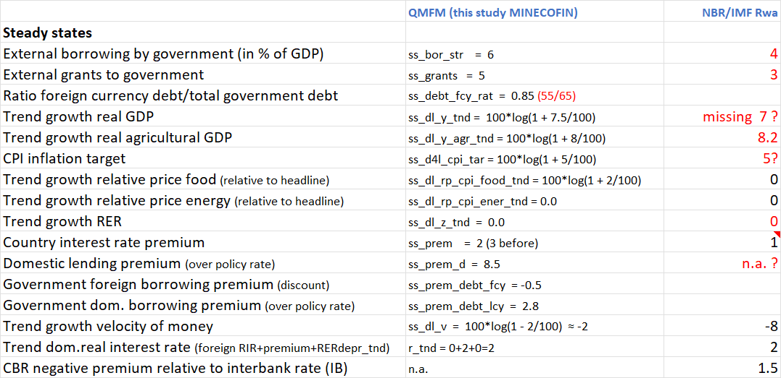

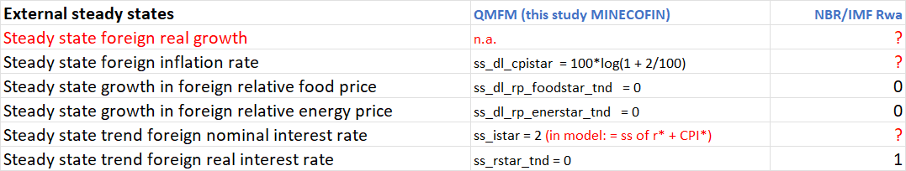

QMFM 2.0—further breakdown of fiscal deficit into three parts

Key enhancement:
- Specifying govt demand for G&S, other expenditure (transfers/subsidies) and revenue

before: govt demand for G&S and deficit, with other expenditure minus revenue implicit)

- Specifying structural, discretionary, and cyclical components for each of three deficit parts

- As before, expressing deficit components in percent of GDP, but some non-linear equations, notably for govt demand G&S, gap and trend

- Maintain steady-state structural deficit (11%, from grants/GDP 5% and target debt/GDP 75%, SS real growth, inflation and RER rates). Now translated into ss-levels of govt demand G&S (Cons. 14%, Inv. 12%), govt other expenditure (6%), and govt revenue (21%).
A3. Main relationships and transmission mechanisms in Quarterly Macro-Fiscal Model
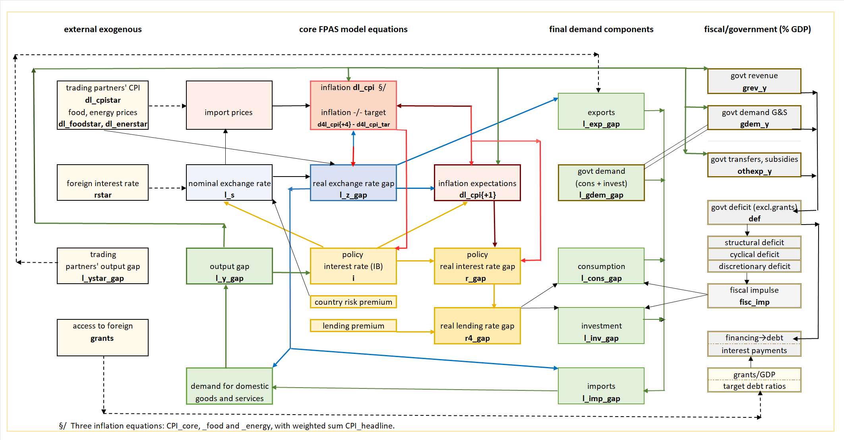

The reduced form of the QMFM model ER equations is:
l_s = e1*e2 * l_s {+1} + (1-e1 + e1*(1-e2) ) * l_s{-1} + (1-e1 + e1*(1-e2)*2) * dl_s_tar/4 - e1 * (i - istar - prem)/4)
0.2*0.2=0.04 0.8 + 0.2*0.8=0.96 0.8 + 0.2 * 0.8*2=1.12 0.2
With our choice of parameters, this gives coefficients of 0.04 for expected ER, 0.96 for lagged ER, 1.12 for target nominal depreciation, and 0.2 for interest rate differential.

The reduced form of NBR model ER equations can be read from the IMF WP—though with uncertainty about the completeness of some formulae (assuming ∆UIP_{t} = l_s_UIP – l_s{-1} and E(l_s{+1}) = l_s{+1} ):

l_s = w*(1-ε1) * l_s {+1} + (w * ε1 + 1 - w) * l_s{-1} + (w * ε1 * 2 + 1-w) * dl_s_tar/4 - w * (i - istar - prem)/4)
0.5*0.2=0.1 0.5*0.8 +1-0.5=0.9 0.5*0.8*2 + 1-0.5=1.3 0 .5
To avoid confusion, the NBR parameter e1 is written as ε1. The target depreciation dl_s_tar/4 is defined almost identically in the two models. The main difference is the NBR’s higher weight for UIP and target depreciation.
The equations for the target NER depreciation rate ( dl_s_tar/4 or ∆s^{Tar} ) in QMFM and NBR-QPM are almost the same (except for a lagged term). However, the inflation deviation term (with negative coefficient: depreciate less if inflation above target) is not well understood. Moreover, the RER gap term (with negative coefficient: depreciate less if REER is undervalued) seems redundant, though it makes for a faster move toward the ERER (l_z_tnd).

Assuming in NBR-IMF (2020): ∆UIP_{t} = l_s_UIP – l_s{-1} and E(l_s{+1}) = l_s{+1}.

